
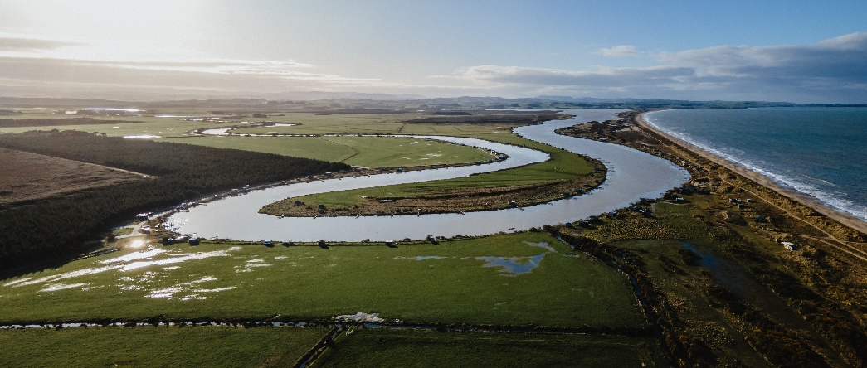
Detailed Agenda with Presentation Overviews and Guest Speaker Information
Thursday 15th June 2023
Croydon Lodge, Gore
Reimagining Mataura Full Stakeholder Wānanga
9 am | Welcome and Introductions - Riki Parata (MC) and Terry Nicholas (PSG Chairperson)
9:10 am | Progress to date and current programme of work - Megan Reid (Director), Louise Dennison (Programme Coordinator)
9:20 am | Community connection
10 am | Morning Tea
10:30 am | Site-specific Projects Introduction and Cattle Flat Project – Louise Dennison (Programme Coordinator)
A brief overview of some of the current site-specific projects.
10:45 am | Thriving Southland: Beyond Regulation Project and Catchment Model - Richard Kyte (Project Lead)
Thriving Southland is a community-led group that connects farmers and members of the community through catchment groups. The Beyond Regulation Project will develop and trial a model that provides scientific landscape data aimed to inform soil greenhouse gases and water quality solutions that meet government-sanctioned environmental targets.
11:10 am | Fulton Hogan: Diamond Peak Gravel Extraction Site  Speaker: Don Chittock (Fulton Hogan NZ Quarries Environment and Sustainability Manager)
The Reimagining Mataura Project is working closely alongside Fulton Hogan and other involved parties to develop a methodology that will allow for the gravel extraction process to create river system improvements at the site. The site’s end goal is that following the completion of gravel extraction the floodplain will be restored and multiple side braids will be created.
11:35 am | Hydrological data - Sarah Mager (Senior Lecturer at Otago University)
An area of focus is the collection of hydrological data and information across the whole Mataura catchment to create a baseline. It is widely recognised that large volumes of data are collected, but this is primarily done at specific sites. We are working on bringing all the different pieces of data and information together to create a whole picture of the river system.
12 pm | Lunch
1 pm | Te Rūnanga o Ngāi Tahu Climate Strategy - Jacqui Caine (Group Head Strategy and Environment)
The strategy provides direction across the whole spectrum of Ngāi Tahu interests, assets, and activities. It will provide guidance and direction to ensure that people are sustained for generations to come and will be specific to unique places and tribal activities. Some actions will require urgent attention, whereas others will develop over the longer term. The strategy is designed to take a proactive approach while preparing for more severe events than those already affecting takiwā and the people in them.
1:45 pm | GNS Science Climate and Sea Level Rise - Lee Chambers (Numerical Groundwater Modeler)
GNS Science undertakes research that seeks to create a cleaner, safer, and more prosperous future for Aotearoa. The NZSeaRise project aims to produce projections of the magnitude, rate of sea-level rise, and vertical land movement at locations around the NZ coastline. It also aims to fill knowledge gaps that currently limit the ability to anticipate and manage future sea-level rise hazards, risks, and impacts.
2:15 pm | Land and Water Science - Andrew Boyce (General Manager)
Land and Water Science is an innovative, research-based, environmental consultancy located in Invercargill. They have been working with various catchment groups across Murihiku. Their work has been a catalyst for many farmers to implement actions and deploy mitigations that will eventually lead to improved environmental outcomes and increased climate resilience.
2:45 pm | Future direction, next 12 months and beyond - Megan Reid and Louise Dennison
3:15 pm | Summary and Closing - Terry Nicholas
3:30 pm | End of full wānanga
To reimagine the Mataura River system by bringing together catchment by design methodologies and mātauranga Māori (Māori knowledge) in order to build cultural, environmental, and economic resilience in the catchment.

